**ASSIGNMENT -2**

**EXERCISE -3**

Simulate the single phase full wave diode rectifier circuit supplied by AC source voltage of 230 V rms, 50 Hz. Capture the output voltage waveform when load is connected as:

1. Resistive load of 10 Ohm (simulate till two cycles with 1e-6 sampling)
2. Capacitive and Resistive load of C=4700uF and R=10 Ohm (simulate till two cycles with 1e-6 sampling)

**SOLUTION:**

1.

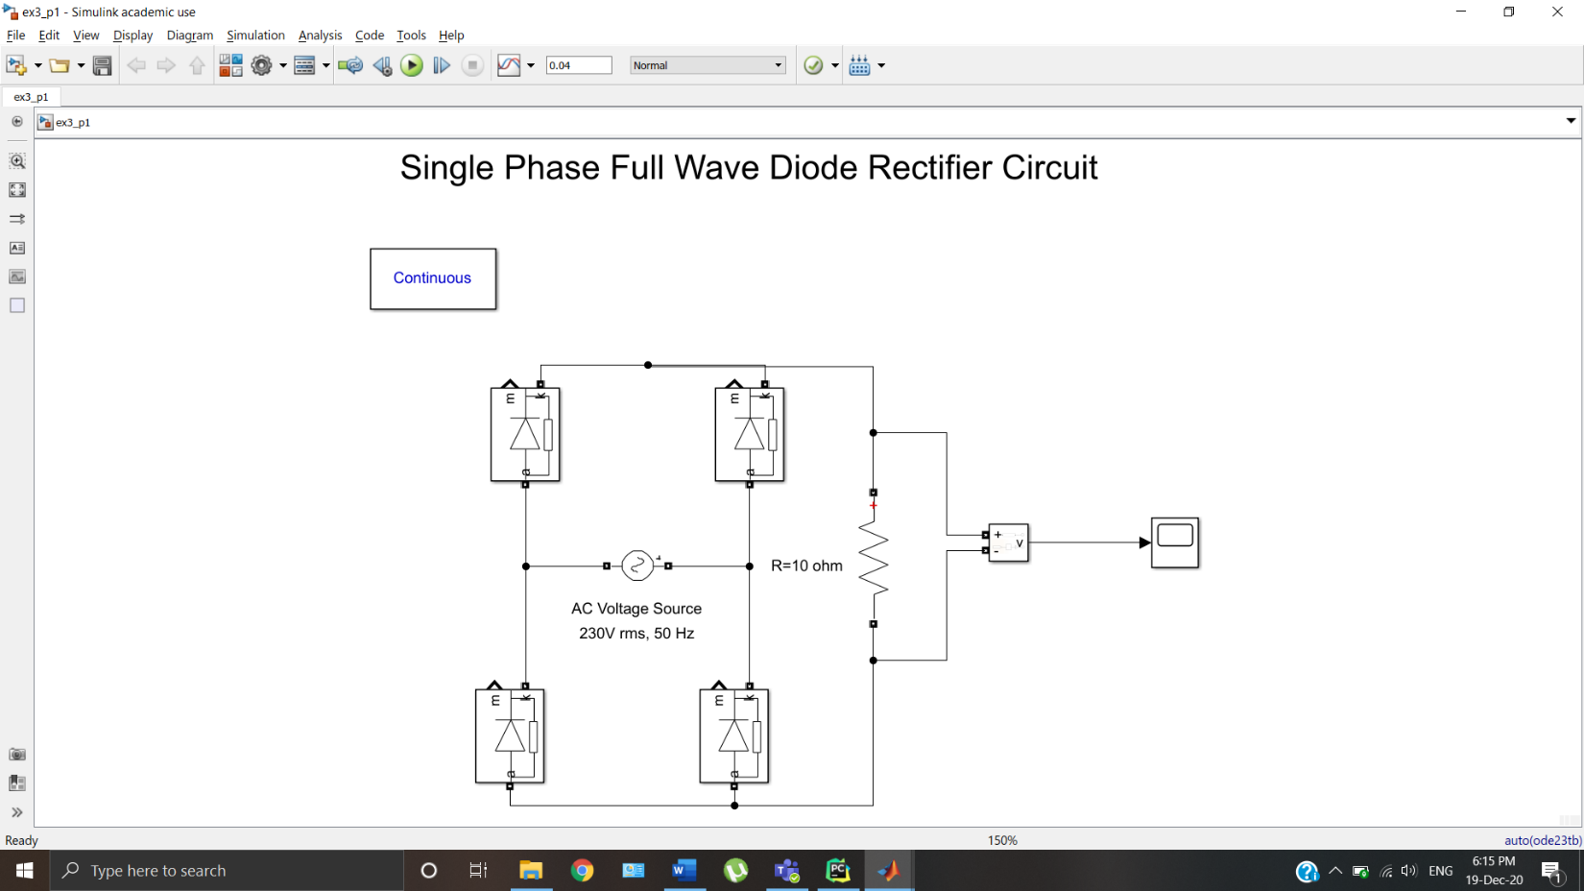

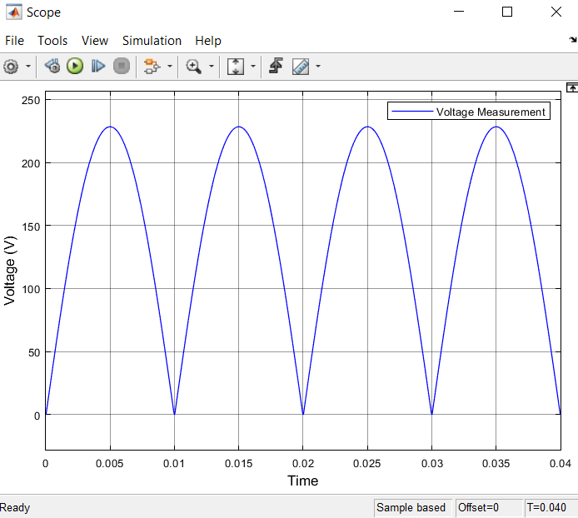

2.

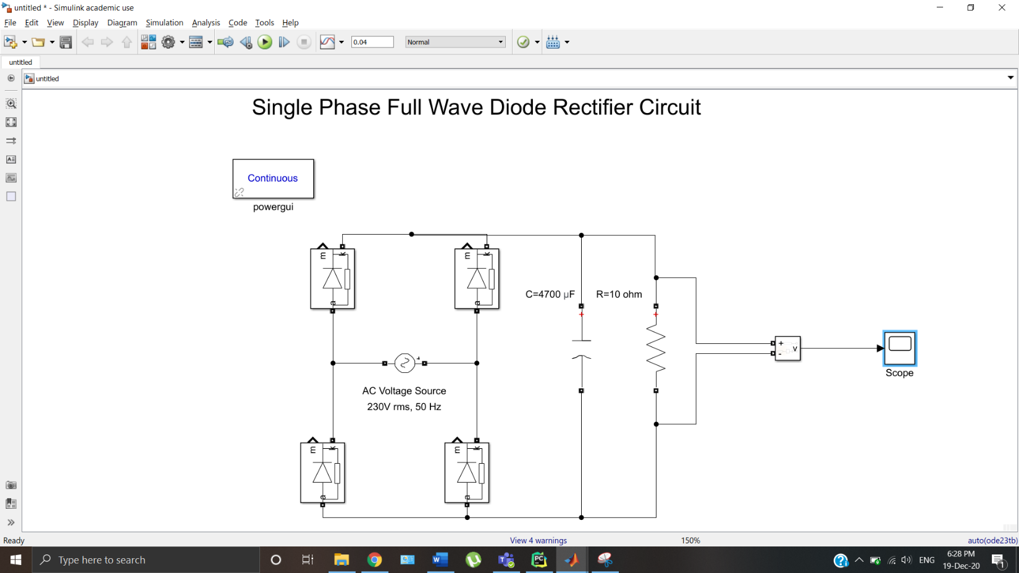

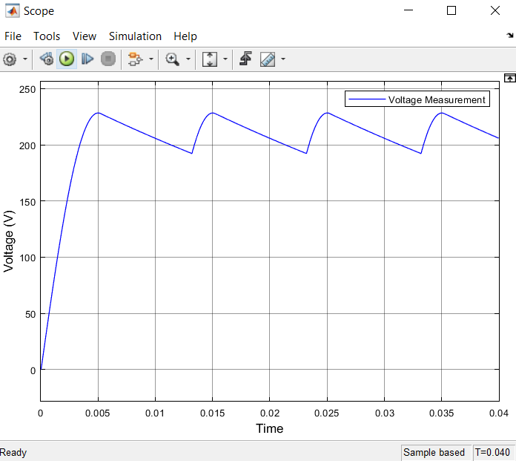

**EXERCISE -4**

Simulate the two stage power conversion AC-DC and DC-DC. Capture the output voltage waveform and measure voltage when duty cycle is

a) 50% (Simulate till 1sec)

b) 95% (Simulate till 1sec)

Specifications:

1. Three phase AC power with 400V line to line voltage rms, 50Hz supply.

2. DC link Capacitor 4700uF.

3. DC-DC Converter with switching frequency 10KHz, L=100mH, C=100uF, Rload=300 Ohm.

**SOLUTION:**

a)

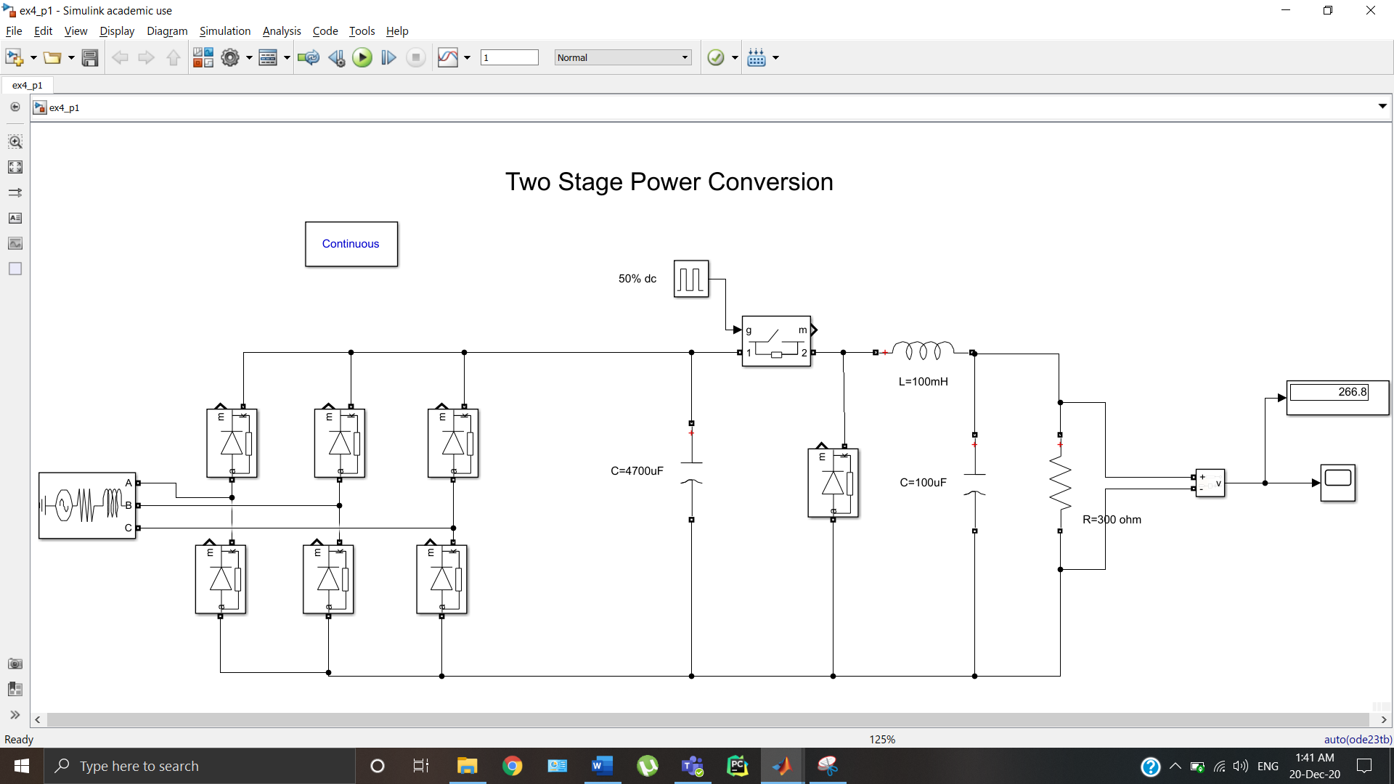

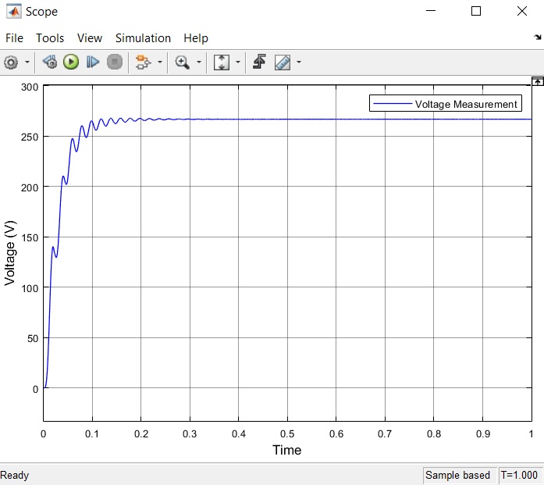

b)

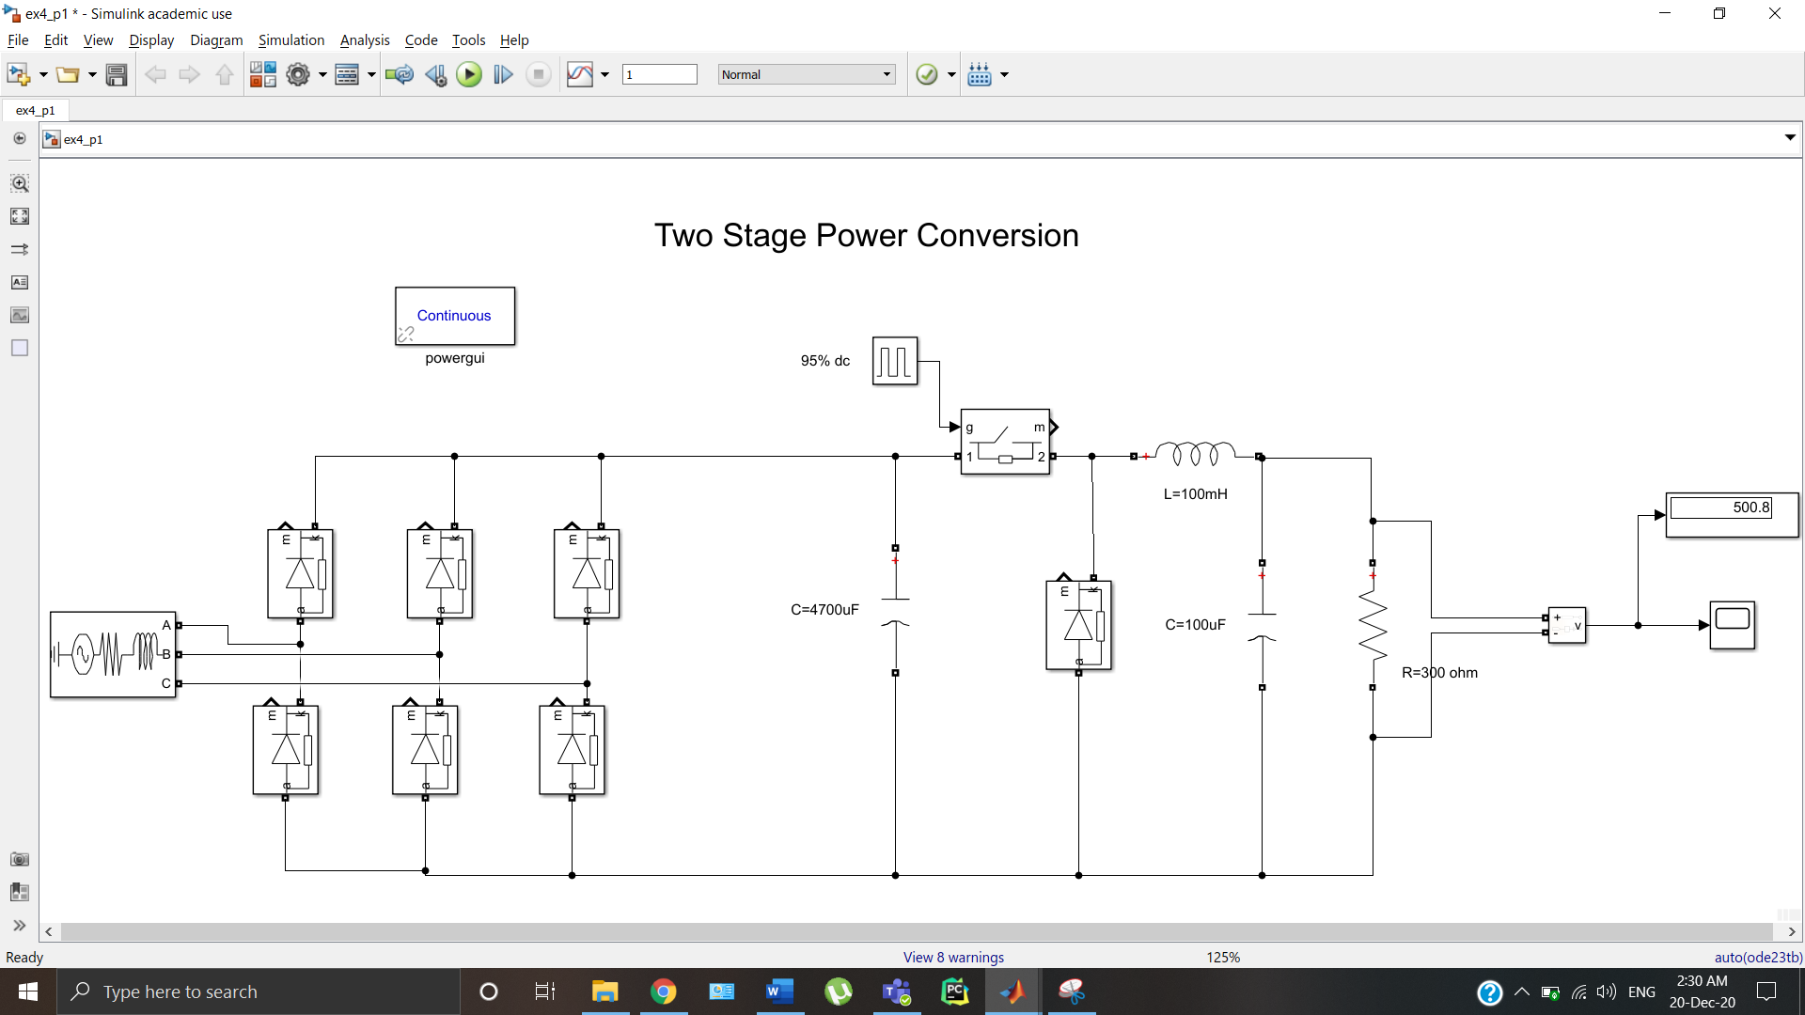

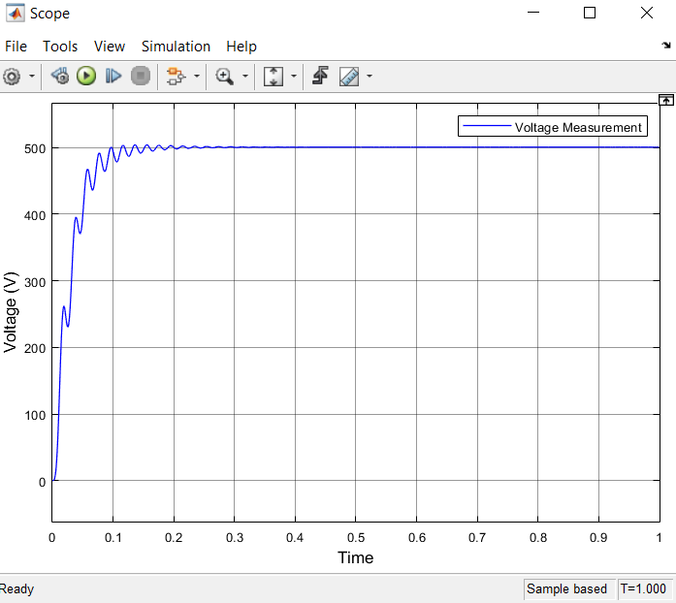

**Proof of concept:**

All the codes and Simulink models can be found at my personal [repository](https://github.com/leander-dsouza/MTE-EDLab).

**END**